Supplementary data

**Table 1 comparative results for different Kernels**

|  |  |  |  |  |  |  |  |
| --- | --- | --- | --- | --- | --- | --- | --- |
| Dataset | P: N | Proposed (Kp,Kc)2 | | Kernel=Kp*Kc | | SVM (linear) | |
| AUC-ROC | AUC-PR | AUC-ROC | AUC-PR | AUC-ROC | AUC-PR |
| NR-  HCPI | 1:1 | **69.98± 5.7** | **77.3± 1.44** | 69.23 ± 5.86 | 75.37 ± 1.27 | 59.31 ± 7.61 | 63.83 ± 2.02 |
| 1:3 | **69.24±4.29** | **76.49±1.85** | 68.85 ± 4.46 | 58.22 ± 2.05 | 59.71 ± 4.6 | 46.67 ± 1.14 |
| 1:5 | **69.15± 4.2** | **61.6±3.44** | 68.61 ± 4.56 | 49.74 ± 2.41 | 61.34 ± 4.46 | 36.83 ± 3.1 |
| 1:7 | **68.1±3.61** | **49.86±2.01** | 68.8 ± 3.33 | 45.67 ± 3.47 | 61.62 ± 4.49 | 37.21 ± 4.02 |

**Experimental setup for screening with Non-redundant Cross-validation (NRCV) or Screening SuperDRUG2**

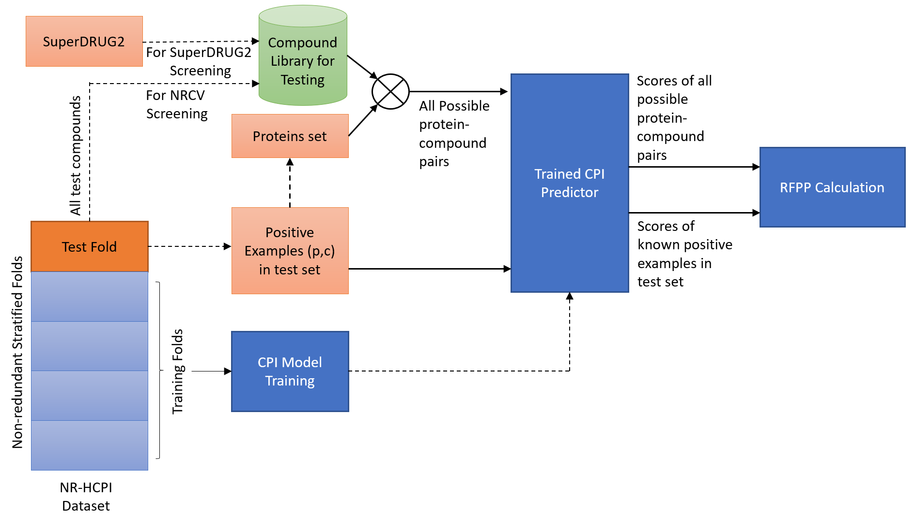

Figure 1 shows the setup of screening experiments used for RFPP calculation.

**Experimental setup for RFPP calculation**

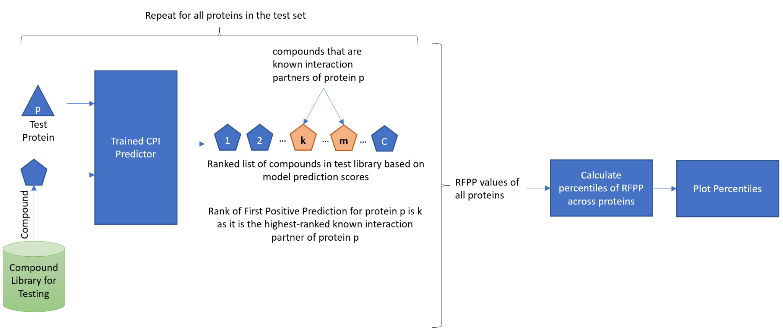

Figure 2 Steps in RFPP calculation

**Table 2 Comparison of non-redundant cross-validation (CV) results of our proposed model with previous method CPI-NN using 40% redundancy removal of HCPI data by CPI-NN NR-HCPI is the non-redundant Human dataset having unique positive examples HCPI and randomly generated negative examples at different P: N ratios mentioned in the table.**

|  |  |  |  |  |  |  |
| --- | --- | --- | --- | --- | --- | --- |
| Dataset | P: N | Total  (P+N) | CPI-NN | | Proposed | |
| AUC-ROC | AUC-PR | AUC-ROC | AUC-PR |
| NR-HCPI  (40%) | 1:1 | 5994 | 92.98 ± 0.87 | 91.62 ± 1.29 | 93.04 ± 0.35 | 93.86 ± 1.01 |
| NR-HCPI (NRCV) (40%) | 1:1 | 5266 | 61.59 ± 0.774 | 71.81± 0.395 | 69.02± 2.44 | 76.8 ± 4.61 |

**Target Compound Screening (TCS) for Drugreprurposing scores for all pairs of proteins in the test set for one fold**

The file can be accessed through this link which has Protein sequence, sorted scores, sorted names, and sorted labels according to the prediction of our model.

[**https://docs.google.com/spreadsheets/d/1sfoRXc8503XZTtT3VA5nQzg1eHA2Dy86/edit?usp=sharing&ouid=111221555398385573178&rtpof=true&sd=true**](https://docs.google.com/spreadsheets/d/1sfoRXc8503XZTtT3VA5nQzg1eHA2Dy86/edit?usp=sharing&ouid=111221555398385573178&rtpof=true&sd=true)

**RFPP of TCS proteins in the test**

The file can be accessed through this link which has protein sequence and RFPP of proteins in the same test set with scores of all pairs in the previous link. [**https://github.com/adibayaseen/HKRCPI/blob/1f91d7b87a8fd910e03d4971dc055c310f230ae4/Target%20Compound%20Screening%20(TCS)%20RFPP%20of%20a%20proteins%20.xlsx**](https://github.com/adibayaseen/HKRCPI/blob/1f91d7b87a8fd910e03d4971dc055c310f230ae4/Target%20Compound%20Screening%20(TCS)%20RFPP%20of%20a%20proteins%20.xlsx)

**Table 4 ACE2’s top 100 Compounds predicted by our proposed model**

|  |  |
| --- | --- |
| ACE2 Median Rank | ACE2Names |
| 1 | glycerol |
| 2 | dexfosfoserine |
| 3 | trandolapril |
| 4 | dimethyl sulfoxide |
| 6 | adenosine triphosphate |
| 6 | ramipril |
| 7 | N-Acetylglucosamine |
| 7 | perindopril |
| 8 | cysteine |
| 9 | cacodylic acid |
| 10 | glycine |
| 11 | sunitinib |
| 12 | mercaptamine |
| 15 | octanoic acid |
| 16 | 1-Octacosanol |
| 16 | diiodohydroxypropane |
| 17 | cetyl alcohol |
| 18 | docosanol |
| 18 | ferric hydroxide |
| 21 | xenon (127Xe) gas |
| 22 | Molybdenum Mo-99 |
| 23 | thallous chloride Tl-201 |
| 23 | glycolic acid |
| 23 | propylene glycol |
| 24 | dimercaprol |
| 25 | cystine |
| 27 | itramin tosilate |
| 29 | dasatinib |
| 30 | krypton (81mKr) gas |
| 30 | inositol |
| 31 | xenon |
| 32 | cholic acid |
| 34 | lactic acid |
| 34 | iodine |
| 35 | trichloroacetic acid |
| 35 | succimer |
| 36 | glutathione |
| 38 | glutamic acid |
| 38 | iodoform |
| 39 | xenon (133Xe) gas |
| 40 | mercuric amidochloride |
| 42 | glucose |
| 43 | galactose |
| 43 | iopydol |
| 44 | bromoform |
| 46 | vorinostat |
| 47 | dodecanoic acid |
| 47 | xylitol |
| 48 | docosanoic acid |
| 48 | sulfur hexafluoride |
| 48 | tetrachloroethylene |
| 49 | stearic acid |
| 49 | ethambutol |
| 52 | aminohydroxybutyric acid |
| 54 | cupric chloride |
| 55 | aluminium oxide |
| 57 | trichloroethylene |
| 58 | mercuric chloride |
| 62 | sorafenib |
| 62 | carbocloral |
| 62 | stannous fluoride |
| 63 | zinc oxide |
| 63 | imatinib |
| 64 | fomepizole |
| 65 | carbon tetrachloride |
| 67 | trometamol |
| 67 | migalastat |
| 68 | thiram |
| 69 | chromic chloride |
| 70 | glucose-1-phosphate |
| 73 | sucrose |
| 74 | algeldrate |
| 74 | fosfestrol |
| 74 | cupric oxide |
| 74 | ferrous chloride |
| 75 | methylpentynol |
| 76 | phenylalanine |
| 77 | lactose |
| 77 | perflunafene |
| 77 | mecysteine |
| 78 | maltose |
| 80 | symclosene |
| 81 | chloralodol |
| 83 | flurotyl |
| 83 | tribromoethanol |
| 84 | pyridoxal phosphate |
| 85 | unithiol |
| 86 | mercuric iodide |
| 87 | aspartic acid |
| 88 | mitolactol |
| 89 | phenol |
| 89 | mitobronitol |
| 90 | pentaerithrityl tetranitrate |
| 93 | pentaerythritol |
| 94 | streptozocin |
| 94 | fytic acid |
| 94 | propiolactone |
| 95 | isosorbide |
| 96 | moroxydine |

Table 5 Sars-Cov-2 Spike protein’s top 100 Compounds predicted by our proposed model

|  |  |
| --- | --- |
| Spike Median Rank | SpikeNames |
| 1 | glycerol |
| 2 | dexfosfoserine |
| 4 | N-Acetylglucosamine |
| 4 | dimethyl sulfoxide |
| 6 | sunitinib |
| 6 | adenosine triphosphate |
| 7 | glycine |
| 9 | cacodylic acid |
| 11 | cysteine |
| 11 | glutamic acid |
| 12 | dasatinib |
| 12 | nilotinib |
| 13 | mercaptamine |
| 13 | sorafenib |
| 14 | cetyl alcohol |
| 15 | docosanol |
| 16 | 1-Octacosanol |
| 20 | cystine |
| 21 | lovastatin |
| 23 | ferric hydroxide |
| 24 | Molybdenum Mo-99 |
| 24 | xenon (127Xe) gas |
| 25 | thallous chloride Tl-201 |
| 25 | glucose |
| 26 | itramin tosilate |
| 26 | galactose |
| 27 | glycolic acid |
| 28 | octanoic acid |
| 29 | trichloroacetic acid |
| 29 | diiodohydroxypropane |
| 30 | xenon |
| 35 | pyridoxal phosphate |
| 37 | aminohydroxybutyric acid |
| 37 | glutathione |
| 38 | iopydol |
| 38 | inositol |
| 40 | krypton (81mKr) gas |
| 41 | glucose-1-phosphate |
| 42 | mercuric amidochloride |
| 42 | streptozocin |
| 43 | dimercaprol |
| 43 | xenon (133Xe) gas |
| 44 | cholic acid |
| 44 | sucrose |
| 44 | voglibose |
| 47 | succimer |
| 48 | iodine |
| 49 | iodoform |
| 50 | lactic acid |
| 50 | lactose |
| 50 | propylene glycol |
| 51 | bromoform |
| 51 | maltose |
| 52 | imatinib |
| 53 | sulfur hexafluoride |
| 54 | stearic acid |
| 54 | aluminium oxide |
| 55 | docosanoic acid |
| 55 | fosfestrol |
| 56 | dodecanoic acid |
| 57 | phenol |
| 59 | propiolactone |
| 60 | aspartic acid |
| 62 | zinc oxide |
| 63 | aminolevulinic acid |
| 63 | mercuric chloride |
| 64 | erlotinib |
| 69 | xylitol |
| 69 | trometamol |
| 72 | fomepizole |
| 73 | migalastat |
| 74 | ethambutol |
| 75 | algeldrate |
| 77 | stannous fluoride |
| 79 | cupric chloride |
| 80 | flurotyl |
| 80 | fludeoxyglucose (18F) |
| 81 | carbon tetrachloride |
| 81 | perflunafene |
| 83 | carbocloral |
| 83 | symclosene |
| 85 | monoctanoin |
| 85 | tetrachloroethylene |
| 85 | thiram |
| 86 | norethisterone |
| 86 | phenelzine |
| 89 | trichloroethylene |
| 89 | mercuric iodide |
| 90 | fludarabine phosphate |
| 91 | chromic chloride |
| 91 | isosorbide |
| 93 | DL-Alanine |
| 94 | alanine |
| 94 | cupric oxide |
| 95 | mitolactol |
| 95 | chloralodol |
| 96 | pentaerythritol |
| 96 | mitobronitol |
| 96 | pentaerithrityl tetranitrate |